**Task-1**

**Title:** Create a webpage that includes a scrolling header message, a table displaying details of your favourite movies (such as name, genre, year, and rating), an image of your favourite actor/actress, a movie trailer video with controls, and an audio player for a movie soundtrack that auto-plays when the page loads.

**Code:**

<!DOCTYPE html>

<html lang="en">

<head>

<meta charset="UTF-8">

<meta name="viewport" content="width=device-width, initial-scale=1.0">

<title>My Movie Fan Page</title>

<style>

body {

font-family: Arial, sans-serif;

text-align: center;

margin: 0;

background-color: #f9f9f9;

}

h1 {

color: blue;

margin-top: 20px;

}

table {

width: 80%;

margin: auto;

border-collapse: collapse;

}

th, td {

border: 1px solid black;

padding: 10px;

text-align: center;

}

th {

background-color: #f2f2f2;

}

.actor img {

width: 150px;

height: auto;

margin: 10px;

border-radius: 8px;

box-shadow: 0 2px 5px rgba(0, 0, 0, 0.2);

}

.trailer iframe {

width: 560px;

height: 315px;

margin: 10px;

box-shadow: 0 2px 5px rgba(0, 0, 0, 0.2);

}

</style>

</head>

<body>

<h1>🎬 Welcome to My Movie Fan Page! 🎬</h1>

<h2>Top 3 Movie Songs</h2>

<table>

<tr>

<th>Movie</th>

<th>Hero</th>

<th>Genre</th>

<th>Year</th>

<th>Rating</th>

</tr>

<tr>

<td>Khaleja</td>

<td>Mahesh babu</td>

<td>Action/comedy</td>

<td>2010</td>

<td>7.6</td>

</tr>

<tr>

<td>RRR</td>

<td>Ram Charan,JNTR</td>

<td>Action/Adventure</td>

<td>2022</td>

<td>7.8</td>

</tr>

<tr>

<td>777 Charlie</td>

<td>Rakshit Shetty</td>

<td>Adventure/Comedy</td>

<td>2022</td>

<td>8.7</td>

</tr>

</table>

<h2>Actor</h2>

<div class="actor">

<img src="C:\Users\KEERTHI\Pictures\khaleja movie poster.jpeg" alt="Mahesh babu">

<img src="C:\Users\KEERTHI\Pictures\RRR movie poster.jpg" alt="Ram Charan,JNTR">

<img src="C:\Users\KEERTHI\Pictures\777 charlie movie poster.jpg" alt="Rakshit Shetty">

</div>

<h2>Trailer</h2>

<div class="trailer">

<iframe width="560" height="315" src="https://www.youtube.com/embed/YraH4F8SdU0" frameborder="0" allowfullscreen></iframe>

<iframe width="540" height="310" src="https://www.youtube.com/embed/W1c2uN3XbKk" frameborder="0" allowfullscreen></iframe>

<iframe width="560" height="315" src="https://www.youtube.com/embed/AFmxPuKecaQ" frameborder="0" allowfullscreen></iframe>

</div>

</body>

</html>

**Output:**

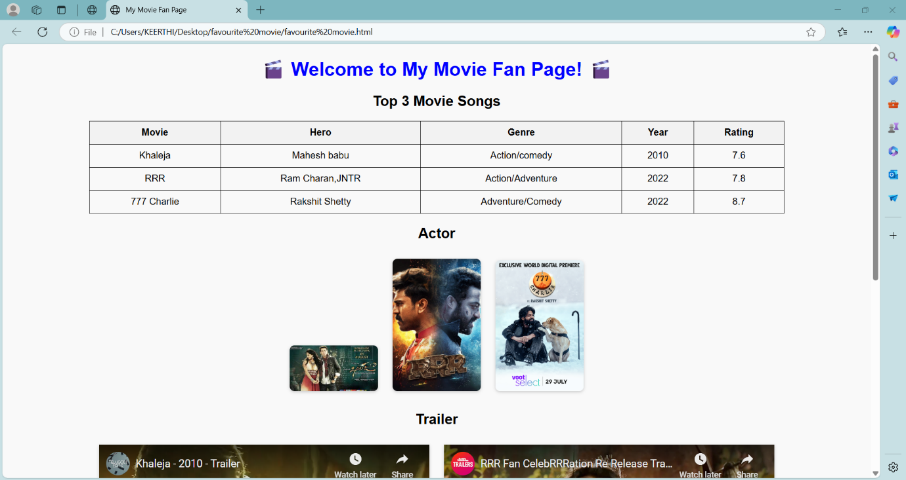

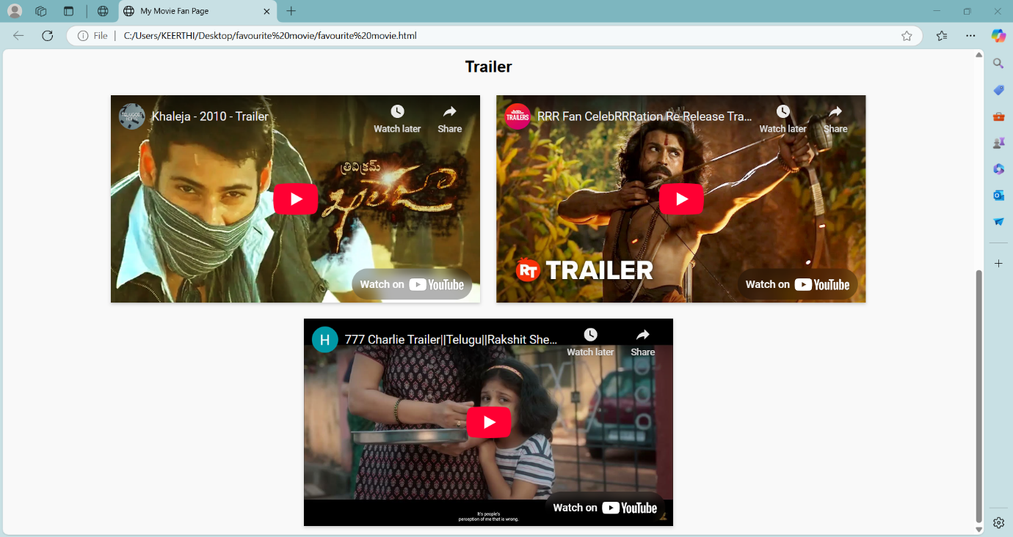

**Task-2**

**Title:** Design a webpage that includes a horizontal navigation menu with links to "Home," "About," "Services," and "Contact," followed by a section that displays a list of your favorite books in a neat table with columns for Title, Author, and Genre. Below the table, insert an image of the book cover for one of the books, a video review of the book, and an audio clip of an author interview.

**Code:**

<!DOCTYPE html>

<html lang="en">

<head>

<meta charset="UTF-8">

<meta name="viewport" content="width=device-width, initial-scale=1.0">

<title>Favorite Books</title>

<style>

body {

font-family: Arial, sans-serif;

margin: 0;

padding: 0;

text-align: center;

}

nav {

background-color: #333;

padding: 10px;

}

nav a {

color: white;

padding: 14px 20px;

text-decoration: none;

display: inline-block;

}

nav a:hover {

background-color: #575757;

}

table {

width: 80%;

margin: 20px auto;

border-collapse: collapse;

}

table, th, td {

border: 1px solid black;

}

th, td {

padding: 10px;

}

.media {

margin-top: 20px;

}

</style>

</head>

<body>

<!-- Navigation Menu -->

<nav>

<a href="#">Home</a>

<a href="#">About</a>

<a href="#">Services</a>

<a href="#">Contact</a>

</nav>

<h2>My Favorite Books</h2>

<!-- Books Table -->

<table>

<tr>

<th>Title</th>

<th>Author</th>

<th>Genre</th>

</tr>

<tr>

<td>Harry potter</td>

<td>J.K.Rowling</td>

<td>fantasy literature</td>

</tr>

<tr>

<td>Alchemist</td>

<td>George Orwell</td>

<td>Dystopian</td>

</tr>

<tr>

<td>Asamardhuni Jeevayatra</td>

<td>Tripuraneni Gopichand</td>

<td>psychological novel</td>

</tr>

</table>

<!-- Multimedia Section -->

<div class="media">

<h3>Featured Book: Harry potter</h3>

<h2>Book Cover Image</h2>

<img src="C:\Users\KEERTHI\Pictures\Harry potter cover page.webp" width="200">

<h2>Video Review</h2>

<div class=Video Review>

<iframe width="560" height="315" src="https://www.youtube.com/embed/YiPSEblAuOo" frameborder="0" allowfullscreen></iframe>

</video>

<h2>Author Interview Audio</h2>

<div class=Author Interview Audio>

<audio controls>

<source src="C:\Users\KEERTHI\Downloads\jk rowling interview.mp3">

</audio>

</div>

</body>

</html>

**Output:**

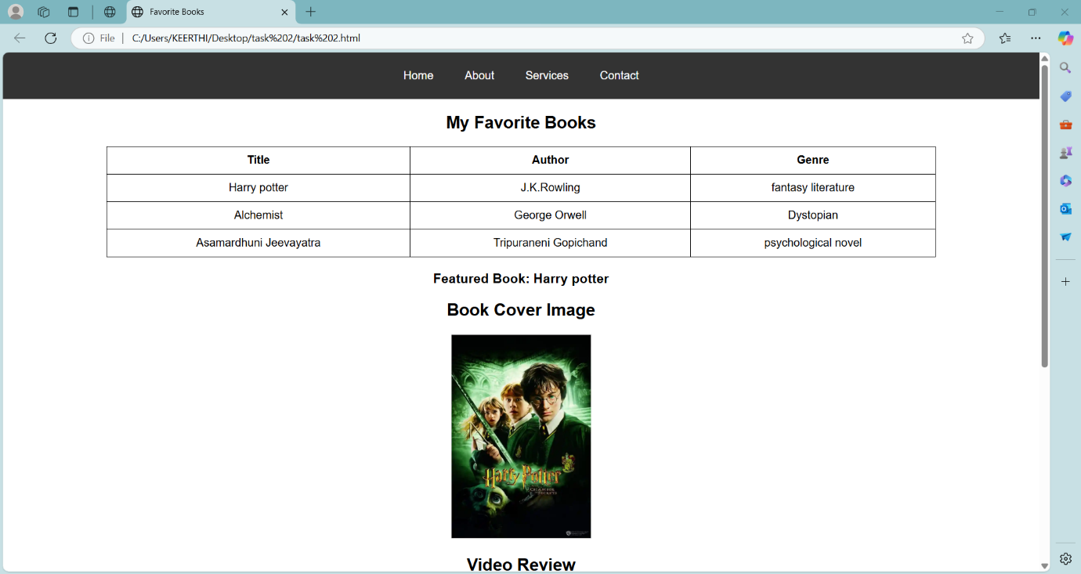

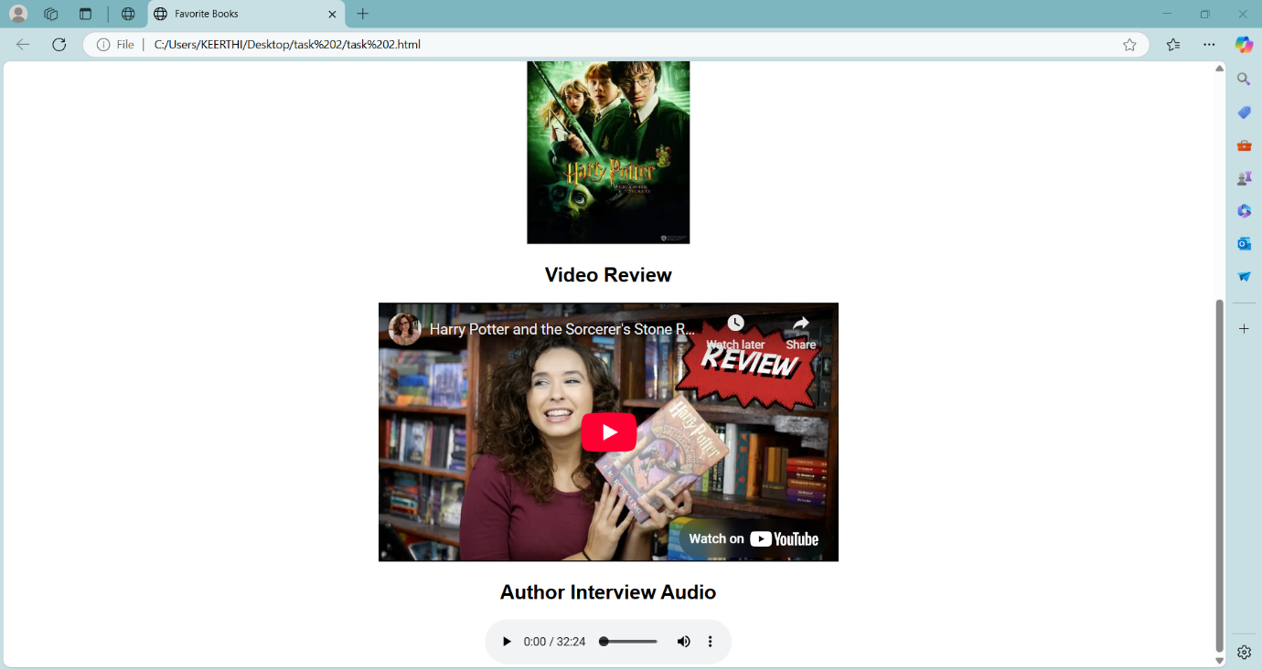

**Task-3**

**Title:** Create a portfolio webpage with a header that scrolls a welcome message across the screen, followed by a section that includes a table of your recent projects with columns for Project Name, Description, and Date. Below the table, add an image of a screenshot from one of the projects, a video tutorial on the project, and an audio description of the project.

**Code:**

<!DOCTYPE html>

<html lang="en">

<head>

<meta charset="UTF-8">

<meta name="viewport" content="width=device-width, initial-scale=1.0">

<title>Keerthi's Portfolio</title>

<style>

body {

font-family: Arial, sans-serif;

margin: 20px;

text-align: center;

}

.scrolling-header {

font-size: 24px;

font-weight: bold;

white-space: nowrap;

overflow: hidden;

width: 100%;

display: block;

color: #333;

}

.scrolling-header span {

display: inline-block;

animation: scrollText 10s linear infinite;

}

@keyframes scrollText {

from { transform: translateX(100%); }

to { transform: translateX(-100%); }

}

table {

width: 60%;

margin: 20px auto;

border-collapse: collapse;

}

th, td {

padding: 10px;

border: 1px solid #333;

}

th {

background-color: #444;

color: white;

}

.media {

margin-top: 20px;

}

</style>

</head>

<body>

<!-- Scrolling Welcome Header -->

<div class="scrolling-header">

<span>Welcome to My Portfolio! Explore My Projects and Creations.</span>

</div>

<h2>Recent Projects</h2>

<!-- Projects Table -->

<table>

<tr>

<th>Project Name</th>

<th>Description</th>

<th>Date</th>

</tr>

<tr>

<td>Interactive Portfolio</td>

<td>A webpage showcasing my skills with multimedia and responsive design.</td>

<td>April 2025</td>

</tr>

<tr>

<td>HTML Audio-Video Integration</td>

<td>Experimenting with autoplay, poster images, and iframe embeds.</td>

<td>March 2025</td>

</tr>

<tr>

<td>Lazy Loading for Web Performance</td>

<td>Optimizing media loading for improved webpage speed.</td>

<td>February 2025</td>

</tr>

</table>

<!-- Multimedia Section -->

<div class="media">

<h3>Project Screenshot</h3>

<img src="C:\Users\KEERTHI\Pictures\interactive portofolio.jpg" alt="Project Screenshot" width="300">

<h3>Video Tutorial</h3>

<iframe width="560" height="315" src="https://youtu.be/TIZ2u8BcSUA" frameborder="0" allowfullscreen></iframe>

<h3>Audio Description</h3>

<audio controls>

<source src="C:\Users\KEERTHI\Music\Interactive Portofolio project audio.mp3" type="audio/mpeg">

</audio>

</div>

</body>

</html>

**Output:**

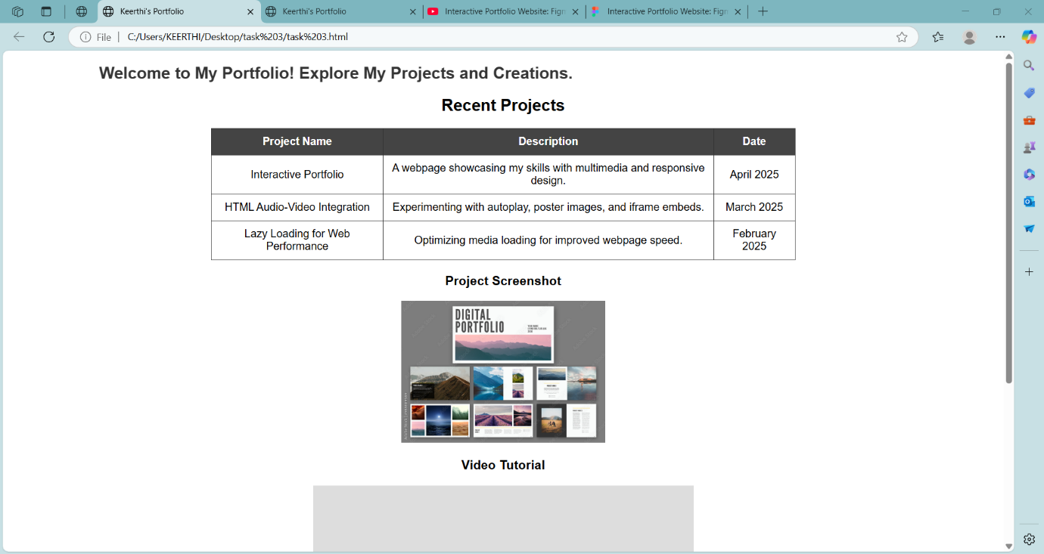

**Task-4**

**Title:** Create a basic HTML page introducing yourself.

**Code:**

<!DOCTYPE html>

<html>

<head>

<title>Introducing myself</title>

</head>

<body>

<h1>Keerthi Penke</h1>

<p>Hi! This is Keerthi. I am studying in Aditya Degree College in the stream of BSC Computer Science 2nd year and I'm a pet lover.</p>

<h2>Hobbies</h2>

<ul>

<li>Reading books</li>

<li>Playing Games</li>

<li>Cooking</li>

**Output:** 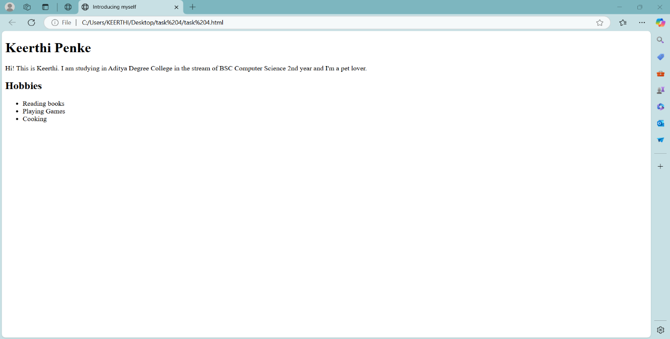

**Task-5**

**Title:** Create a simple resume web page using HTML.

**Code:**

<!DOCTYPE html>

<html>

<body>

<title>Resume</title>

<h1>Keerthi Penke</h1>

<p>A hardworking and dedicated student with a passion for innovation and technology. Seeking opportunities to apply theoretical knowledge and hands-on skills to contribute effectively to projects, fostering continuous learning and growth.</p>

<h2>Skills</h2>

<ul>

<li>Machine Learning</li>

<li>HTML</li>

<li>Problem Solving</li>

</ul>

<h3>Qualifications</h3>

<ol>

<li>Bachelor of Computer Science</li>

<li>Intermediate</li>

<li>SSC</li>

</ol>

</body>

</html>

**Output:**

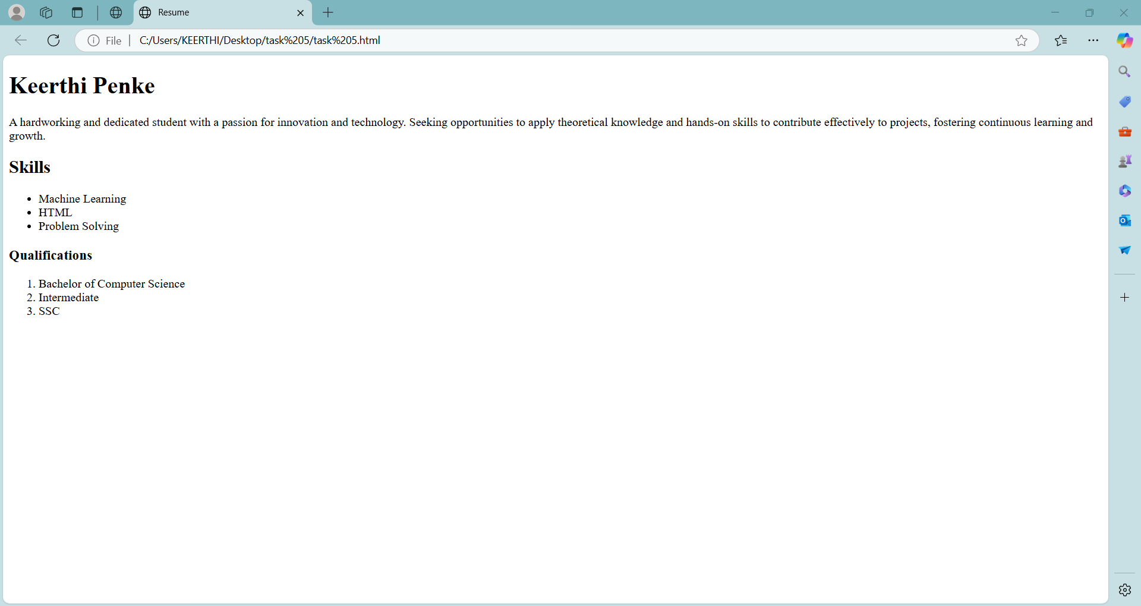

**Task-6**

**Title:** Create a paragraph demonstrating the following text formaƫng tags:

**Code:**

<!DOCTYPE html>

<html>

<head>

<title>text formatting tags</title>

</head>

<body>

<h2>Dogs</h2>

<p>Dogs are <b>loyal and loving companions</b>known for their intelligence and playful nature.They come in various <strong>breeds, sizes, and temperaments,</strong>making them suitable pets for different lifestyles.Dogs provide <i> emotional support, protection,</i>such as guiding visually impaired individuals or working in <em> search-and-rescue operations.</em>Their keen senses, especially their <u> strong sense of smell, </u> make them excellent trackers. <mark> With proper care, training, and affection, dogs form deep bonds with their owners,</mark> offering unconditional love and companionship. Whether playing in the park or simply resting beside their human, <small> dogs bring joy and warmth to countless households.</small>

</body>

</html>

**Output:**

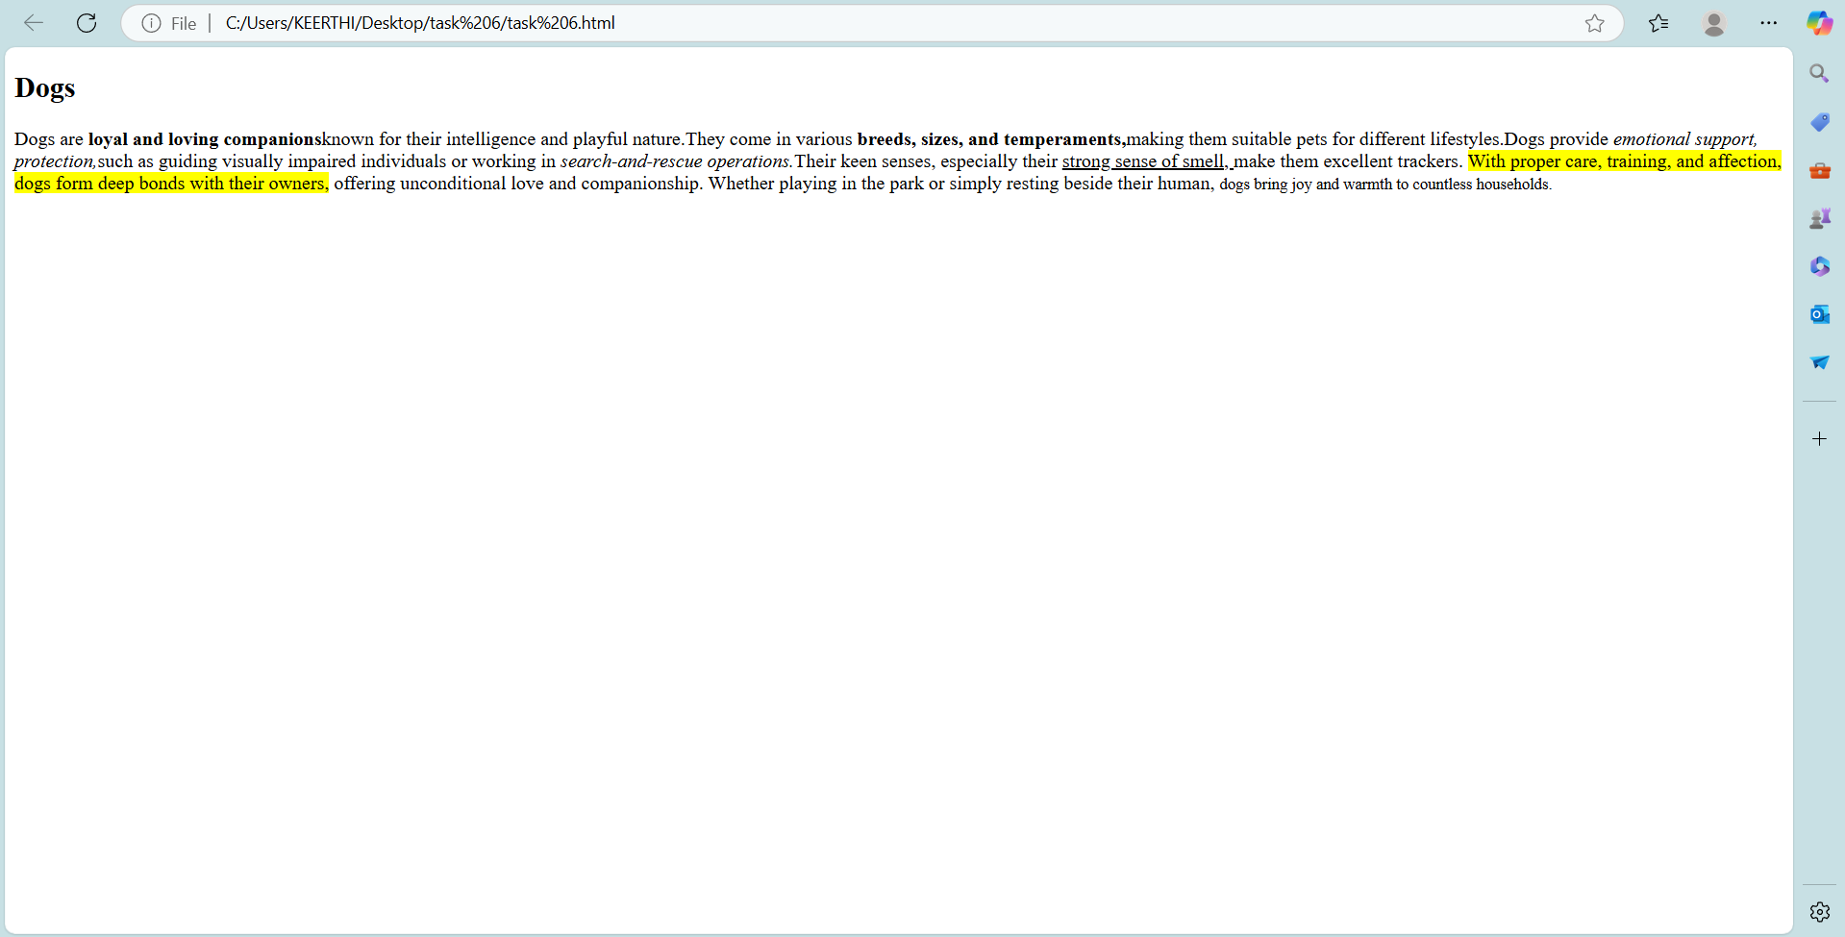

**Task-7**

**Title:** Create a nested list of a shopping category.

**Code:**

<!DOCTYPE html>

<html>

<head>

<title>Shopping Category</title>

</head>

<body>

<h1>Shopping Category</h1>

<h2>Fruits</h2>

<ul>

<li>Apple</li>

<li>Mango</li>

<li>Guava</li>

</ul>

<h2>Vegetables</h2>

<ul>

<li>Brinjal</li>

<li>Tomato</li>

<li>Potato</li>

</ul>

<h3>Electronics</h3>

<ul>

<li>Laptop</li>

<li>Smart phone</li>

<li>Computer</li>

</ul>

**Output:**

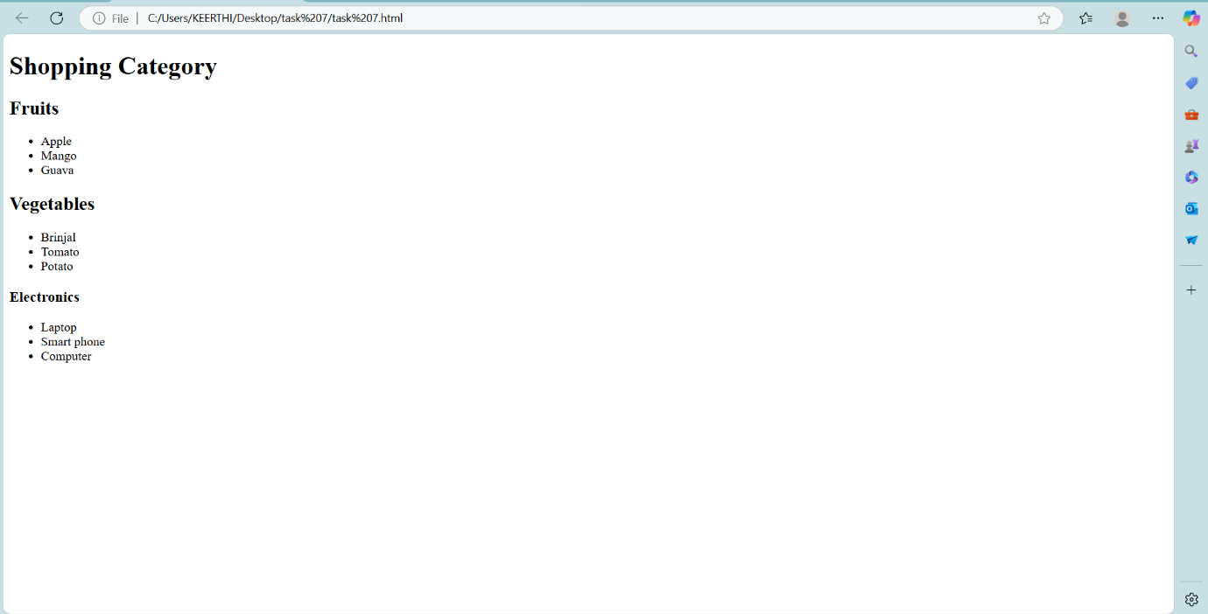

**Task-8**

**Title:** Create an ordered list of your semester subjects.

**Code:**

<!DOCTYPE html>

<html>

<head>

<title>Semester Subjects</title>

</head>

<body>

<h1>Semester Subjects</h1>

<ol type="I" start="4">

<li>Database Management System</li>

<li>Object Oriented Software Engineering</li>

<li>Data Communication Network</li>

<li>Amazon Web Services</li>

<li>Data Mining Warehouse</li>

</ol>

</ol>

</body>

</html>

**Output:**

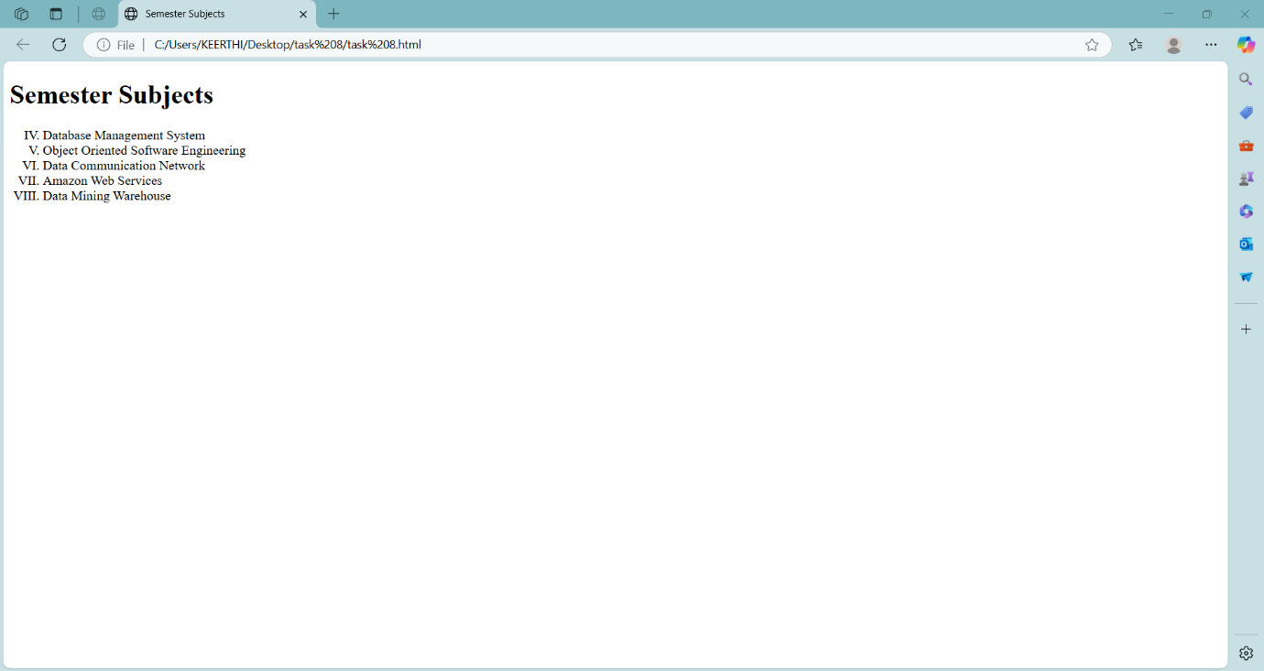

**Task-9**

**Title:** Create a student marks table using HTML table tags

**Code:**

<!DOCTYPE html>

<html>

<head>

<title>HTML Table Tag</title>

</head>

<body>

<table border="1">

<tr>

<th>Name</th>

<th>Subject</th>

<th>Marks</th>

<th>Grade</th>

</tr>

<tr>

<td>Keerthi</td>

<td>Maths</td>

<td>95</td>

<td>A+</td>

</tr>

<tr>

<td>Jyotsna</td>

<td>Science</td>

<td>90</td>

<td>A</td>

</tr>

<tr>

<td>Pooja</td>

<td>Social</td>

<td>80</td>

<td>B+</td>

</tr>

<tr>

<td>Amrutha</td>

<td>English</td>

<td>90</td>

<td>A</td>

</tr>

</table>

</body>

</html>

**Output:**

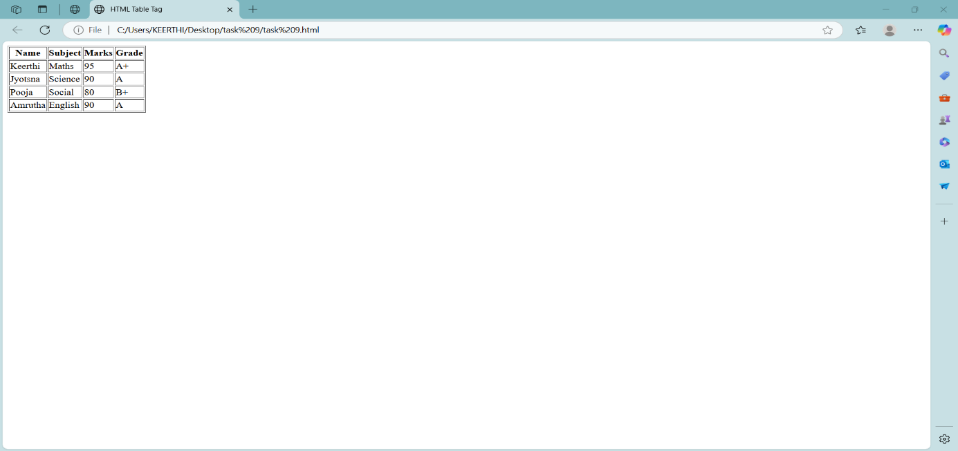

**Task-10**

**Title:** Create a webpage that displays two images using the <img> tag.

**Code:**

<!DOCTYPE html>

<html>

<head>

<title>Two Images with Specified Sizes</title>

</head>

<body>

<img src="C:\Users\KEERTHI\Pictures\sunset.jpg"Image 1 - A placeholder image" height="300" width="300">

<img src="C:\Users\KEERTHI\Pictures\Saved Pictures\Golden Retriver Image.webp "height="500" width="400">

</body>

</html>

**Output:**

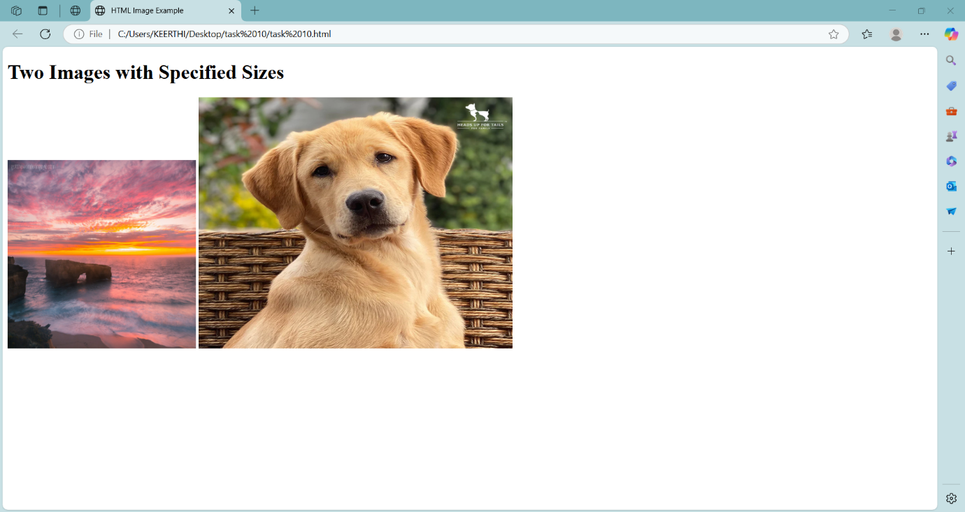

**Task-11**

**Title:** Create a multimedia demo page using HTML.

**Code:**

<!DOCTYPE html>

<html>

<head>

<title>Multimedia Demo</title>

</head>

<body>

<h1>Multimedia Demo</h1>

<video src="C:\Users\KEERTHI\Videos\Tangled part1.mp4" controls width="600" height="400"></video>

<audio src="C:\Users\KEERTHI\Music\[iSongs.info] 01 - Premalo.mp3" controls></audio>

</body>

</html>

**Output:**

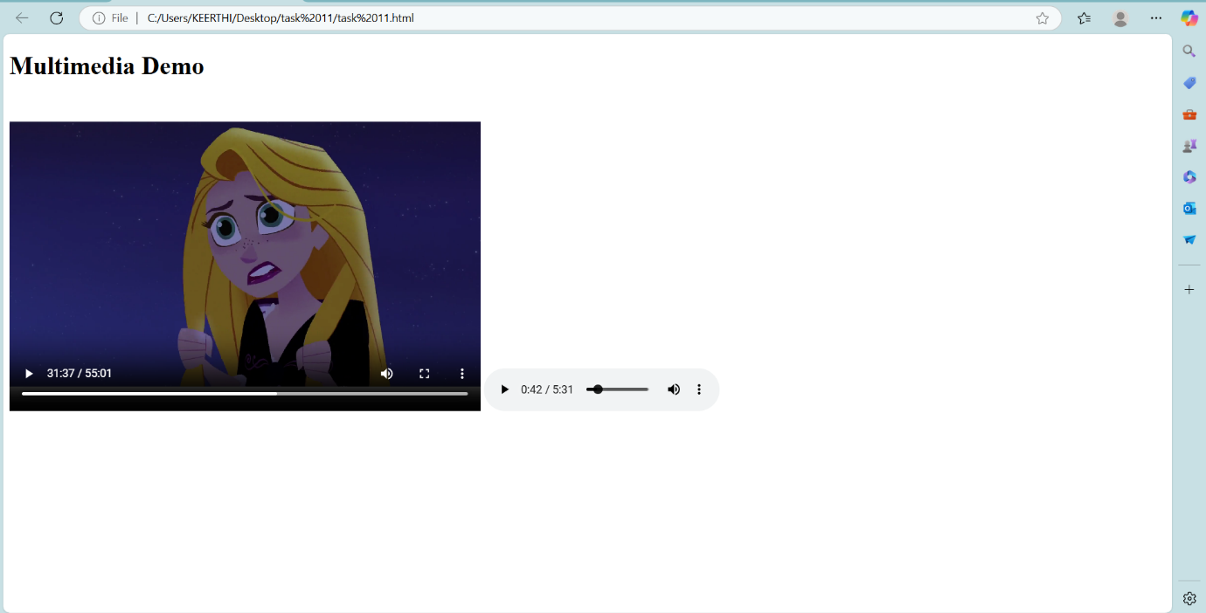

**Task-12**

**Title:** Create a styled section using the <div> tag. The <div> should contain:

**Code:**

<!DOCTYPE html>

<html>

<head>

<title>Div Container Example</title>

</head>

<body>

<div style="border: 10px solid black; padding: 10px;">

<h2>Notification</h2>

<p>A notification is a message that Android displays outside your app's UI to provide the user with reminders, communication from other people, or other timely information from your app.</p>

</div>

</body>

</html>

**Output:**

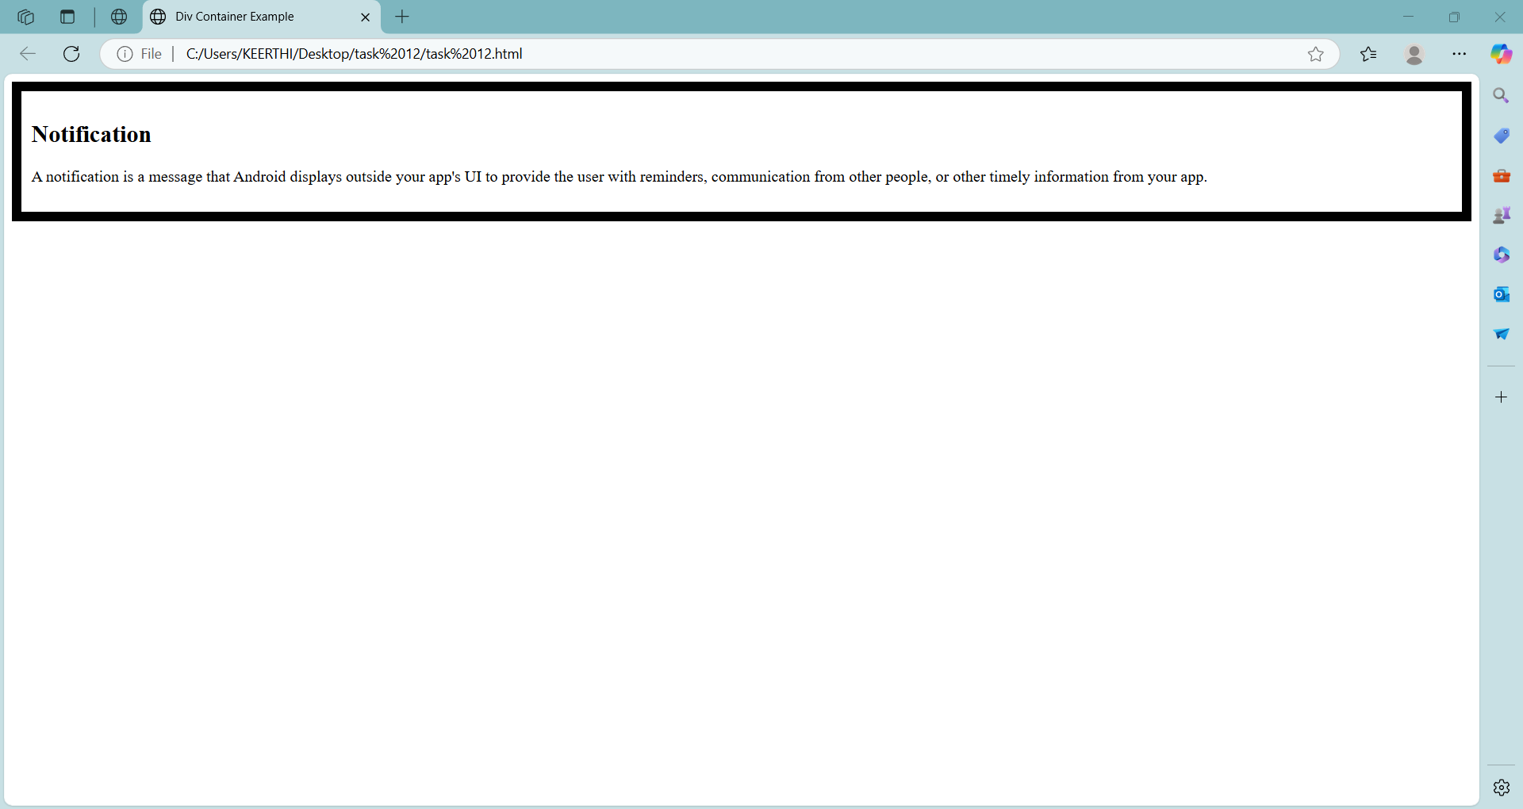

**Task-13**

**Title:** Create a scrolling marquee using the <marquee> tag.

**Code:**

<!DOCTYPE html>

<html>

<head>

<title>Marquee Tag Example</title>

</head>

<body>

<h2>Scrolling Text Example</h2>

<marquee>Welcome to our website! Stay tuned for updates. </marquee>

<marquee direction="down" bgcolor="white" width="50%" height="200px">

<img src="C:\Users\KEERTHI\Desktop\Waterfall image.jpg" alt="Scrolling Image1"> </marquee>

<marquee direction="up" bgcolor="white" width="50%" height="200px">

</body>

</html>

**Output:**

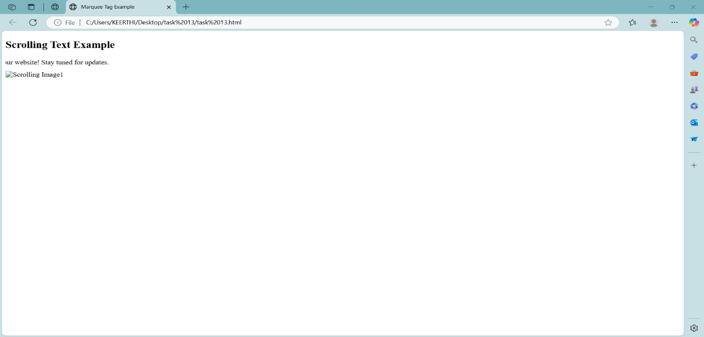

**Task-14**

**Title:** Create a web page with a background image.

**Code:**

<!DOCTYPE html>

<html>

<head>

<title>Image Background</title>

</head>

<body background="C:\Users\KEERTHI\Downloads\WhatsApp Image 2025-04-26 at 11.44.26.jpeg" >

<p>Laptops are portable computers designed to be carried around, making them ideal for use in

various locations like home, office, or on the go. They are powered by rechargeable batteries, </p>

</body>

</html>

**Output:**

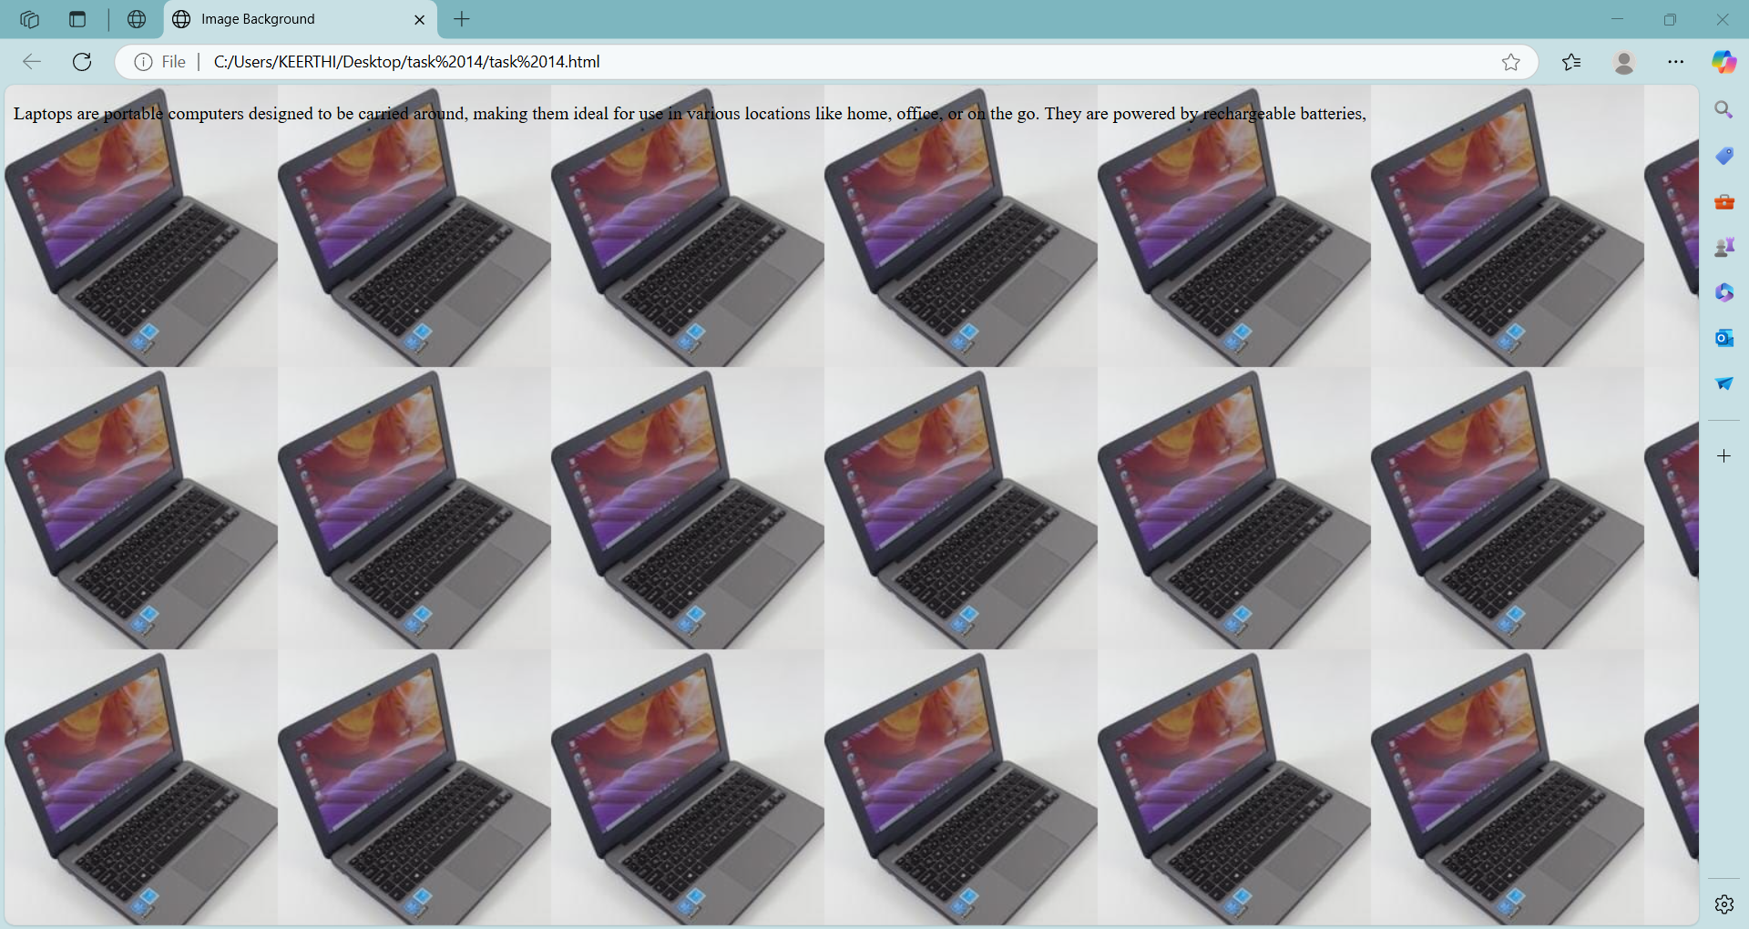

**Task-15**

**Title:** Create a Student Registration Form Design a simple registration form with the following fields:

**Code:**

<!DOCTYPE html>

<html>

<head>

<title> Student Registration form </title>

</head>

<body>

<h1> Student Registration Form</h1>

<form>

Name: <input type="text"><br><br>

Email: <input type="text"><br><br>

<h2>Select Your Gender</h2>

<input type="radio" name="gender" value="male">Male<br><br>

<input type="radio" name="gender" value="female">Female<br><br>

<input type="radio" name="gender" value="other">Others<br><br>

<h2>Courses Interested </h2>

<input type="checkbox" name="skills" value="C">C<br><br>

<input type="checkbox" name="skills" value="Java">Java<br><br>

<input type="checkbox" name="skills" value="Python">Python<br><br>

<input type="checkbox" name="skills" value="HTML">HTML<br><br>

<h2>Location</h2>

<select name="location">

<option value="Hyderabad">Hyderabad</option>

<option value="Vizag">Vizag</option>

<option value="Vijayawaada">Vijayawada</option>

</select>

<h2>About Yourself</h2>

<form>

<textarea name="comments" rows="4" cols="50"></textarea>

<h2>Already Registered</h2>

<a href="https://www.login.com="target="_blank">Click here to login</a>

</form>

</body>

</html>

**Output:**

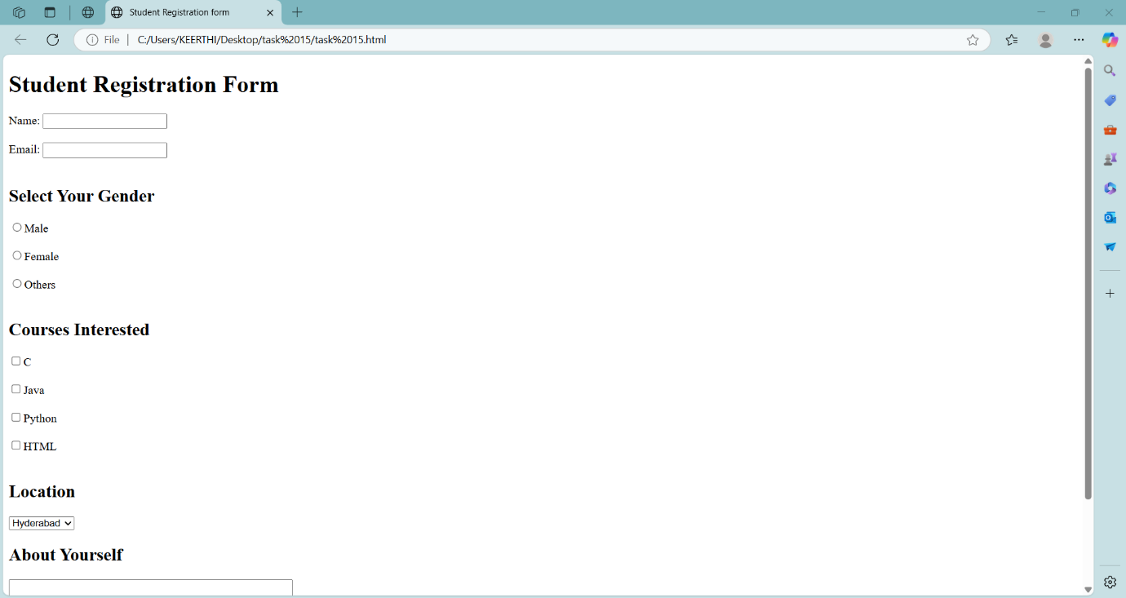

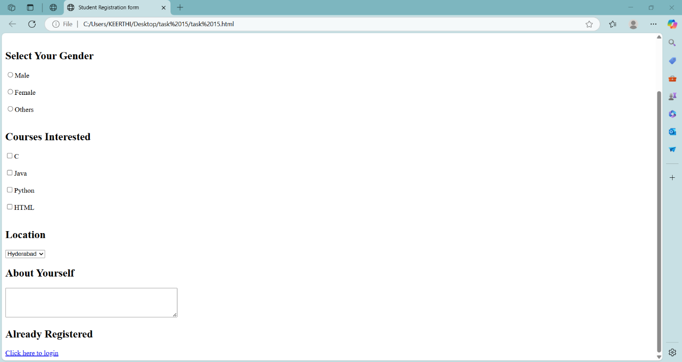

**Task-16**

**Title:** Online Course Enrollment Page.

**Code:**

<html>

<head>

<title>Online Course Enrollment Page</title>

</head>

<body>

<h1>Online Course Enrollment</h1>

<div class="container">

<p>Online courses are important because they offer flexible, accessible, and affordable learning opportunities for people around the world. They allow individuals to learn at their own pace, often from top institutions or experts.</p>

<img src="nptel.jpg" alt="Online Learning" width="200" height="200"></img>

<form>

Student Name:<input type="text"><br><br>

Student Age: <input type="number"><br><br>

<h2>Select Your Course</h2>

<select name="Course">

<option value="">--Select Course--</option>

<option value="java">java</option>

<option value="html">html</option>

<option value="Python">Python</option>

<option value="C++">C++</option>

<option value="others">Others</option>

</select>

<h2>Choose Your Learning Mode:</h2>

<select name="mode">

<option value="">--Select mode--</option>

<option value="Online">Online</option>

<option value="Offline">Offline</option>

<option value="Hybrid">Hybrid</option>

</select><br><br>

<form>

<input type="checkbox" name="terms" value="I agree to the terms and conditions">I agree to the terms and conditions<br><br>

</form>

<h2>Additional Comments:</h2>

<textarea name="comments" rows="10" cols="50"></textarea><br><br>

<button type="submit">Submit</button>

</form>

</div>

</body>

</html>

**Output:**

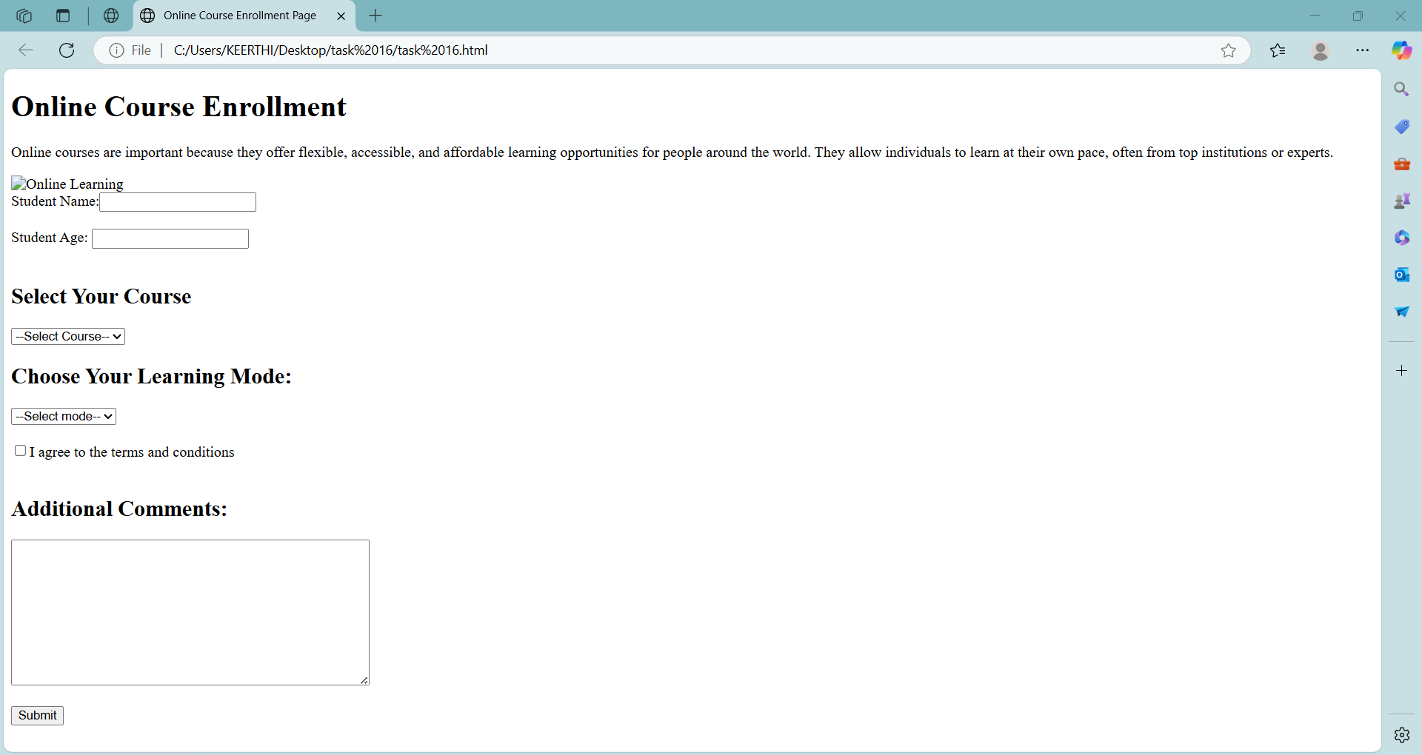

**Task-17**

**Title:** Feedback Form for a Website Instructions: Create a feedback form that asks users:

**Code:**

<!DOCTYPE html>

<html>

<head>

<title>Online Course Enrollment Page</title>

</head>

<body>

<h1>FeedBack Form</h1>

<form>

Name:<input type="text"><br><br>

Email:<input type="text"><br><br>

<h2>How did you hear about the website?</h2>

<form>

<input type="radio" name="source" value="google"> Google</input>

<input type="radio" name="source" value="social_media"> Social Media</input>

<input type="radio" name="source" value="friend"> Friend</input>

<input type="radio" name="source" value="others"> Others</input>

</form>

<h2>What did you like the most?</h2>

<form>

<input type="checkbox" name="like" value="ui Design"> UI Design</input>

<input type="checkbox" name="like" value="speed"> Speed</input>

<input type="checkbox" name="like" value="content"> Content</input>

<input type="checkbox" name="like" value="responsive"> Responsiveness</input>

</form>

<h2>Rate us:</h2>

<select name="Rate us">

<option value="">--Select--</option>

<option value="⭐">1 Star</option>

<option value="⭐⭐">2 Stars</option>

<option value="⭐⭐⭐">3 Stars</option>

<option value="⭐⭐⭐⭐">4 Stars</option>

<option value="⭐⭐⭐⭐⭐">5 Stars</option>

</select>

<h2>Leave a message or comment:</h2>

<textarea name="message" rows="20" cols="50"></textarea>

<button type="submit">Submit Feedback</button>

</form>

<a href=target="_blank">Back to Homepage</a>

</form>

</body>

</html>

**Output:**

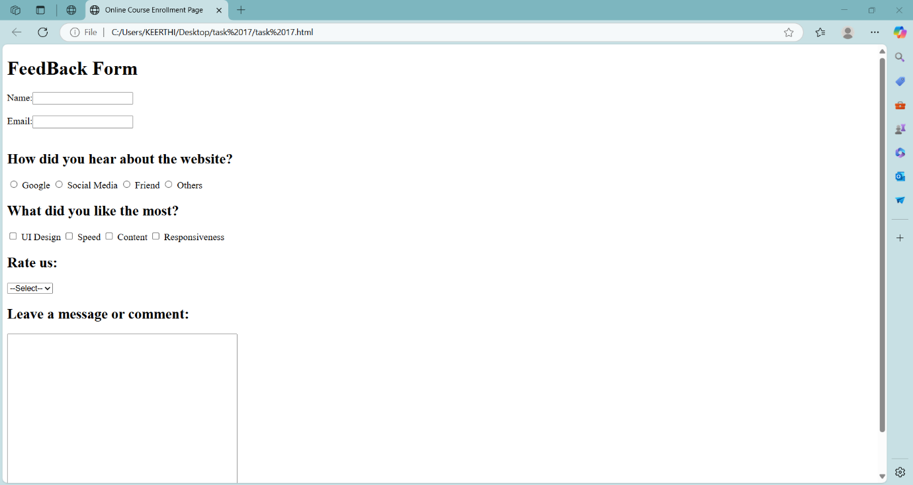

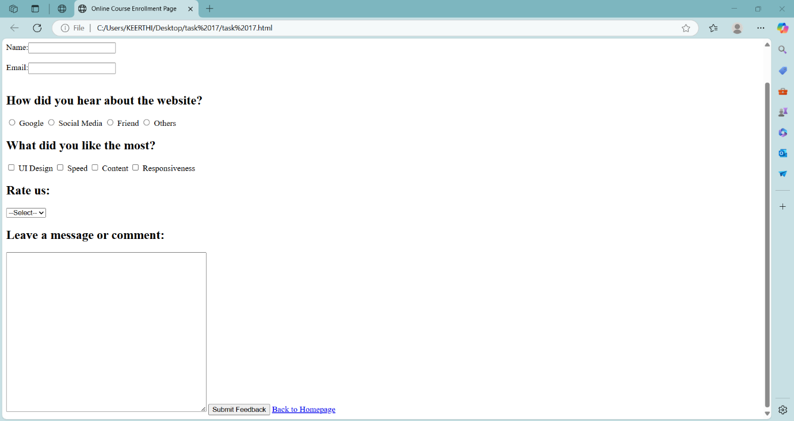

**Task-18**

**Title:** College Event Signup Page Instructions:

**Code:**

<!DOCTYPE html>

<html>

<head>

<title>Aditya Degree College Tech Fest 2025</title>

</head>

<body>

<marquee><h2>Aditya Degree College Tech Fest 2025</h2></marquee>

<form>

<h3>Welcome to the Aditya Degree College Tech Fest 2025!</h3>

<video src="aditya.mp4" height="300" width="350" type="video/mp4" controls></video>

<h2>Event Schedule</h2>

<table border="2" padding="50px">

<tr>

<th>Event Name</th>

<th>Timing</th>

</tr>

<tr>

<td>Singing Competition</td>

<td>10:00 AM - 11:00 PM</td>

</tr>

<tr>

<td>SCI-LAND Program </td>

<td>11:30 PM - 12:30 PM</td>

</tr>

<tr>

<td>Project Show Program</td>

<td>1:00 PM - 3:00 PM</td>

</tr>

<tr>

<td>Students Dance Program</td>

<td>3:00 PM - 4:30 PM</td>

</tr>

<tr>

<td>Code developing Program</td>

<td>4:30 PM - 5:00 PM</td>

</tr>

</table>

<h2>Register Here</h2>

<form>

Full Name: <input type="text"><br><br>

Phone Number:<input type="number"><br><br>

<h2>Department:</h2>

<select name="Department">

<option value="Computer Science">Computer Science</option>

<option value="Electronics">Electronics</option>

<option value="Air">Air</option>

<option value="Data Science">Data Science</option>

<option value="B.com">B.com</option>

</select>

<h2>Select Events you want to Participate In:</h2>

<form>

<input type="checkbox" name="event1"> Singing Competition</label>

<input type="checkbox" name="event2"> SCI-LAND Program</label>

<input type="checkbox" name="event3"> Project Show Program</label>

<input type="checkbox" name="event4"> Students Dance Program</input>

<input type="checkbox" name="event5"> Code developing Program</input>

</form>

<h2>Past Experience (if any):</h2>

<text area name="experience" rows="20" cols="50"></text area>

<button type="submit">Register</button>

</form>

<h3>Below the link</h3>

<a href="https://www.youtube.com/shorts/8AQNFraRMn8?feature=share"_blank ">Click here to view full event details</a>

</form>

</body>

</html>

**Output:**

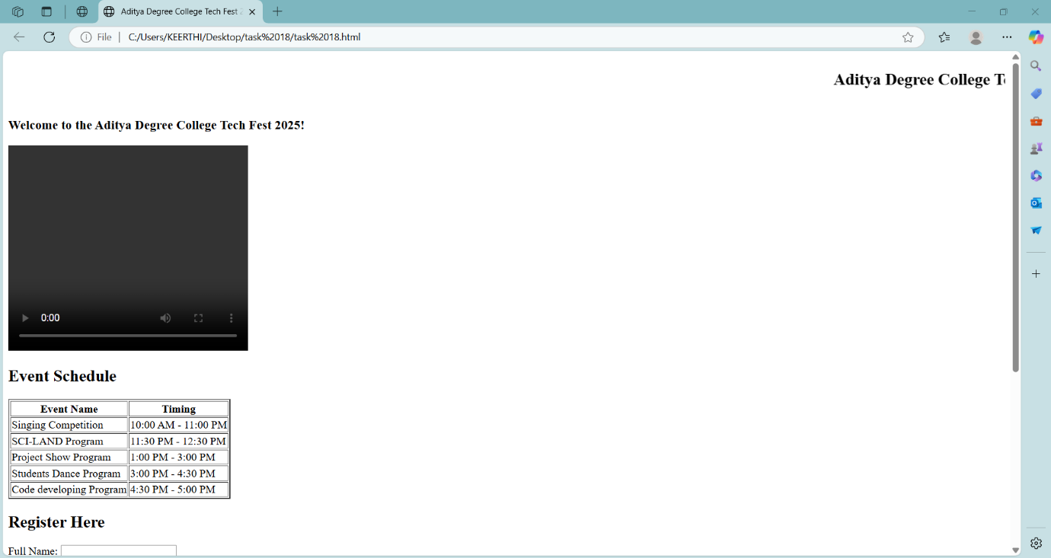

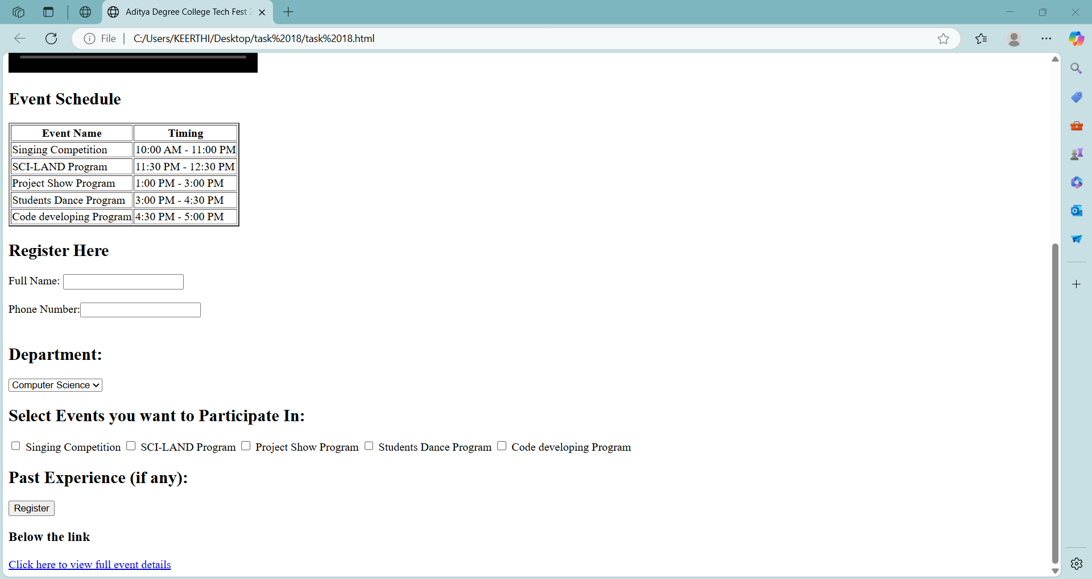

**Task-19**

**Title:** Job Application Form

**Code:**

<!DOCTYPE html>

<html>

<head>

<title>Job Application Form</title>

</head>

<body>

<form>

<h1>Job Application Form</h1>

<form>

Applicant Name: <input type="text"><br><br>

Email ID: <input type="email"><br><br>

<h2>Preferred Job Role:</h2>

<select name="role">

<option value="Backend Developer">Backend Developer</option>

<option value="Frontend Developer">Frontend Developer</option>

<option value="Full Stack Developer">Full Stack Developer</option>

</select>

<h3>Skills:</h3>

<form>

<input type="checkbox" name="skills" value="html"> HTML</input>

<input type="checkbox" name="skills" value="c"> C</input>

<input type="checkbox" name="skills" value="python"> Python</input>

<input type="checkbox" name="skills" value="java"> Java</input>

</form>

<label>Upload Resume:</label>

<h2>Why do you want this job?</h2>

<textarea name="about" rows="5" cols="60"></textarea><br><br>

<button type="submit">Submission</button>

</form>

<h3>Below the company link</h3>

<a class="company-link" href="https://www.techspark.com" target="_blank">Visit our company page</a>

</div>

</body>

</html>

**Output:**

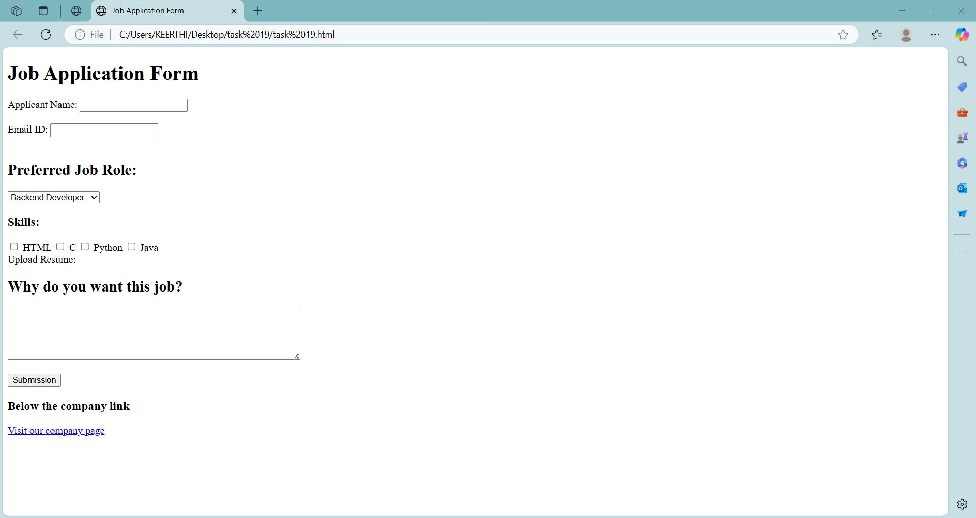

**Task-20**

**Title:** Create a personal website homepage that includes:

**Code:**

<!DOCTYPE html>

<html>

<head>

<title>My Personal Website</title>

</head>

<body>

<header>

<h1></h1>

<nav>

<a href="#">home</a> |

<a href="#">Projects</a> |

<a href="#">Contact</a>

</nav>

</header>

<div>

<article>

<h2> My Background</h2>

<p>

i am beginner of the <ins>coding and web development</ins> , "i have a problem solving Skills and Communication skills".

</p>

</article>

<section>

<img src="C:\Users\KEERTHI\Pictures\Screenshots\Screenshot 2025-05-02 183007.png" width="300" height="300"></img>

<p>it's me, i like to solve coding error.</p>

</section>

</div>

</body>

</html>

**Output:**

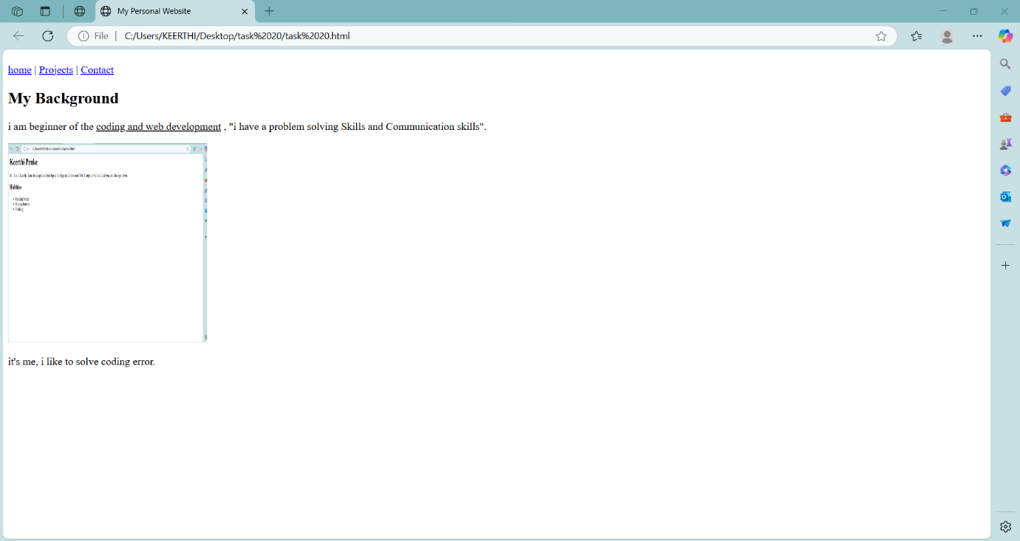

**Task-21**

**Title:** Design a layout with two vertical panels:

**Code:**

<!DOCTYPE html>

<html>

<head>

<title>two vertical paneles</title>

</head>

<frameset cols="50%,50%">

<frame src="https://www.codecademy.com" noresize>

<frame src="https://www.wikipedia.org" >

</frameset>

</html>

**Output:**

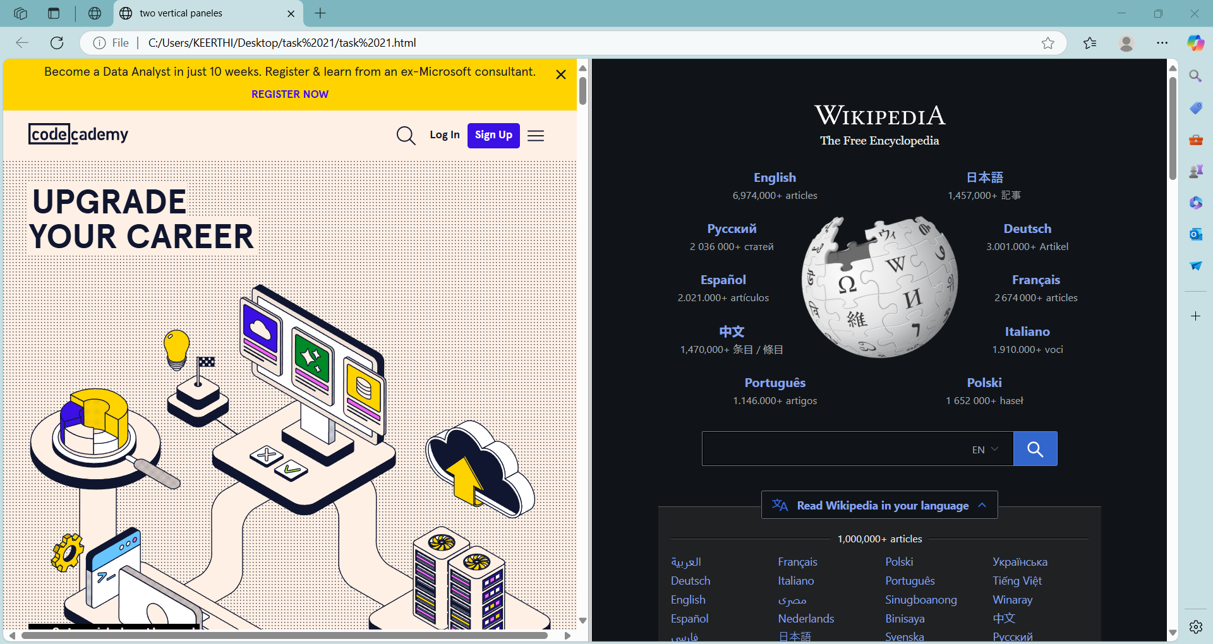

**Task-22**

**Title:** Build a form for event registration:

**Code:**

<!DOCTYPE html>

<html>

<head>

<title>Event Registration Form</title>

</head>

<body>

<h2>Event Registration Form</h2>

<form>

Name: <input type="text"></input><br><br>

ph no. : <input type="number"></input><br><br>

Email: <input type="Email" ></input><br><br>

<div>

<h3>Gender:</h3>

<input type="radio" name="gender" value="male">Male<br>

<input type="radio" name="gender" value="female">female<br>

<input type="radio" name="gender" value="other">Other<br>

</div>

<div>

<h3> Multiple Interests:</h3>

<input type="checkbox" name="course" value="music">Music<br>

<input type="checkbox" name="course" value="Sports">Sports<br>

<input type="checkbox" name="course" value="Art">Art<br>

</div>

<form>

<h3>Location</h3>

<select name="location">

<option value="Hyderabad">Hyderabad</option>

<option value="Vizag">Vizag</option>

<option value="Vijayawada">Vijayawada</option>

</select>

</form>

<h3>Comment box</h3>

<textarea name="comments" rows="4" cols="20"></textarea>

<div class="submit-button">

<input type="submit" value="Register">

<input type="submit" value="submit">

</div>

<button onclick="showConfirmation()">Trigger</button>

<script>

function showConfirmation() {

const result = confirm("Are you sure you want to proceed?");

if (result) {

alert("Submitted your degtails Confirmed!");

} else {

alert("Cancelled!");

}

}

</script>

</form>

</body>

</html>

**Output:**

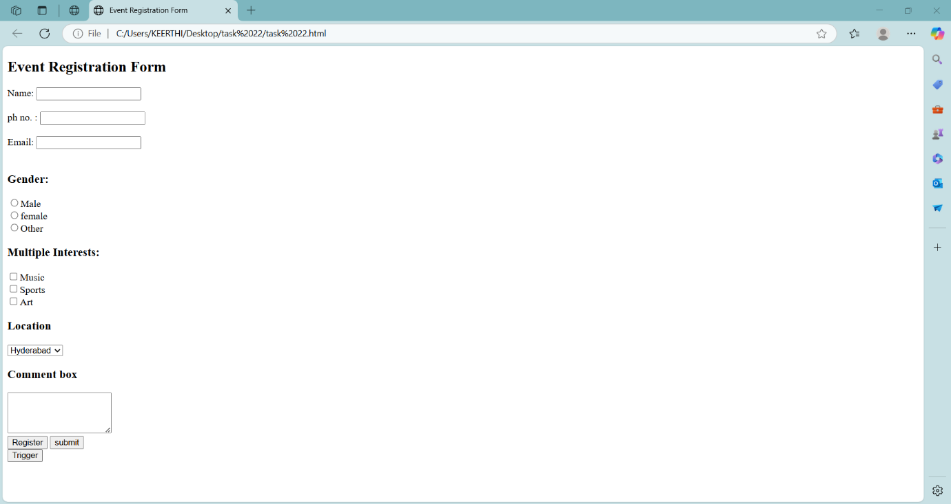

**Task-23**

**Title:** Create a single webpage layout that includes:

**Code:**

<!DOCTYPE html>

<html>

<head>

<title>Single Webpage</title>

</head>

<body>

<form>

<section class="news">

<h2>Today's Headline</h2>

<h3>| What's the debate about |</h3>

<p>Caste census: Rahul claims (made Modi govt implement our vision). Will it cut ice

For two years, Rahul Gandhi has made caste census the centrepiece of his social justice agenda. Govt announcement to hold the same comes with pointed attacks at the Congress.</p>

</section>

<section class="tips & ads">

<h2>Tips & Ads</h2>

<ul>

<li>Tip: Stay updated with indian express to stay competitive.</li>

<li>Ad: Check out our new updates only watch in Indian Express News</li>

</ul>

</section>

<footer>

<p>Copyright © 2025 The Indian Express [P] Ltd. All Rights Reserved</p>

<p> Contact :<a href="mailto:indianexpress143@gmail.com">indianexpress143@gmail.com</a></p>

</footer>

</form>

</body>

</html>

**Output:**

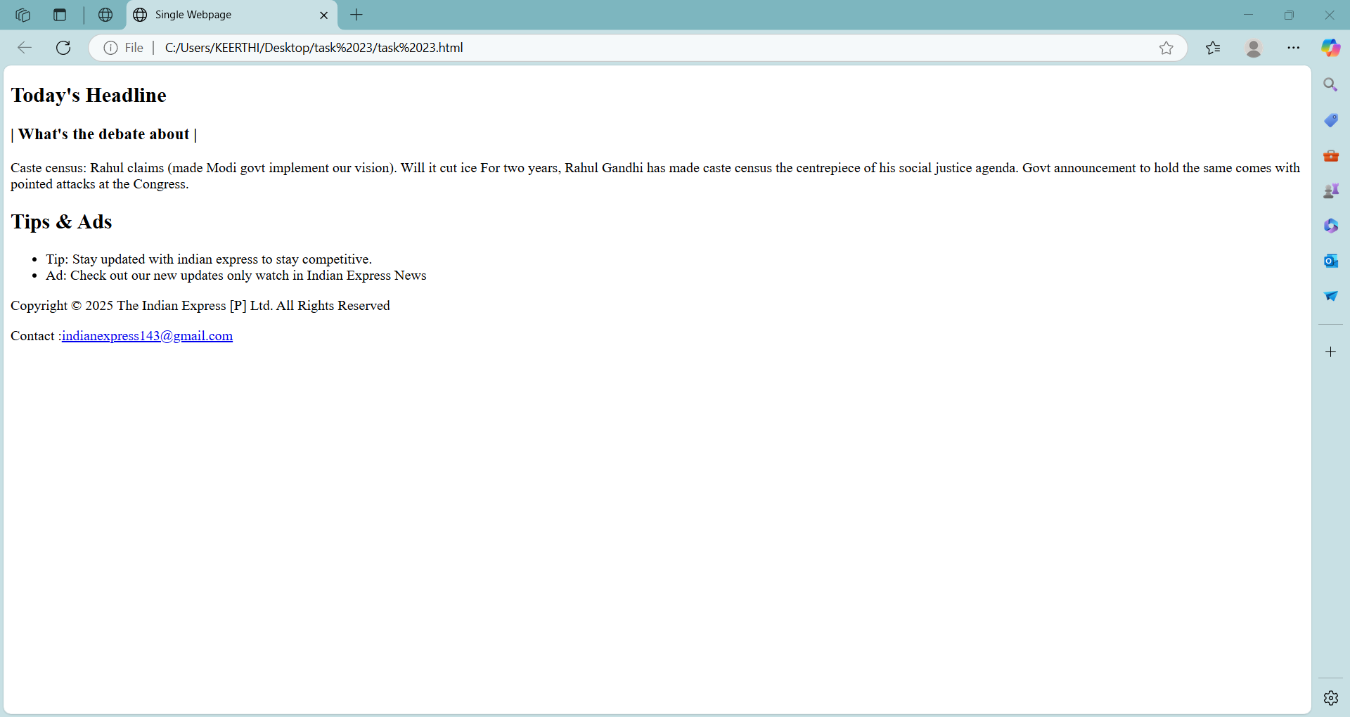

**Task-24**

**Title:** Build a payment selection form that groups options like UPI, Credit Card, and Cash on Delivery under one box.

**Code:**

<!DOCTYPE html>

<html>

<head><title>Payment Selection</title></head>

<body>

<form>

<fieldset>

<h2>Payment Method</h2>

<label>

<input type="radio" name="pay" value="upi">UPI<br>

<input type="radio" name="pay" value="credit-card">Credit Card<br>

<input type="radio" name="pay" value="cod">Cash on Delivery<br>

</label>

</fieldset>

</form>

</body>

</html>

**Output:**

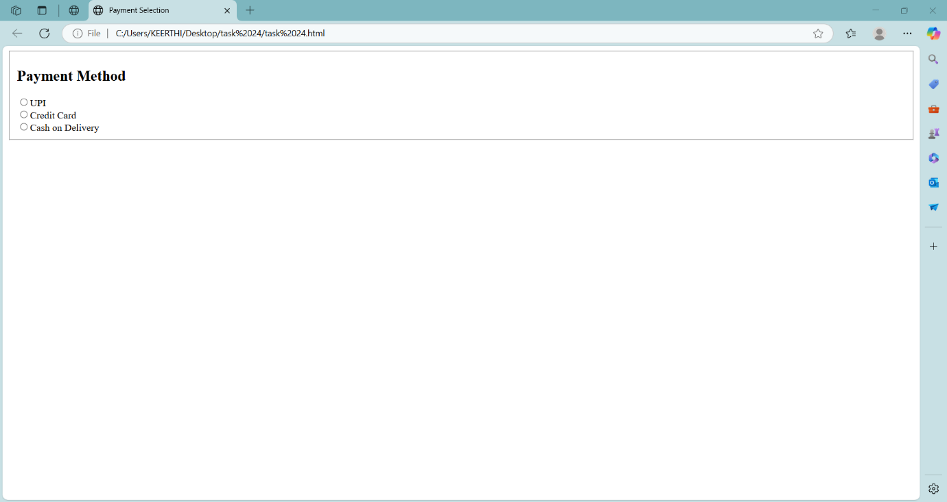

**Task-25**

**Title:** Display a product offer:

**Code:**

<!DOCTYPE html>

<html>

<head>

<title>Product Offer</title>

</head>

<body>

<fieldset>

<h2>Product Offer</h2>

<p> The new shirt Original prize is <del>$1999</del></p>

<p> Now its discounted price is <mark>$999</mark> only</p>

<h4>Note:</h4>

<p><u>There is no extra cost for new model pieces</u></p>

</fieldset>

</body>

</html>

**Output:**

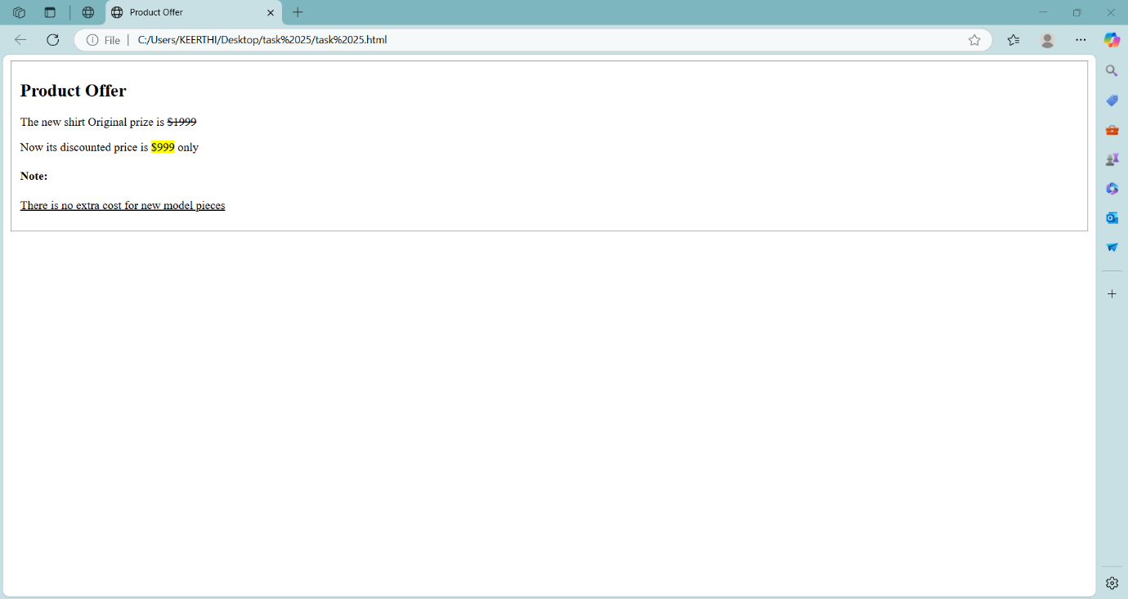

**Task-26**

**Title:** Design a layout for a blog:

**Code:**

<!DOCTYPE html>

<html>

<head>

<title>Blog Example</title>

</head>

<body>

<header>

<h1>My Travel Blog</h1> <nav>

<a href="#home">Home</a> |

<a href="#destinations">Destinations</a> |

<a href="#contact">Contact</a> |

<a href="#Gallery">Gallery</a>

</nav>

</header>

<div>

<article>

<h2>Lambasingi Trip</h2>

<p>Last winter season i visited at the location. Lambasingi is renowned as the "Kashmir of Andhra Pradesh" and is famous for being the only place in South India where snowfall occasionally occurs.</p>

</article>

<section>

<h3>Travel Tips</h3>

<ul>

<li>You have to wear Hoodie.</li>

<li>You have to take Camera for Pictures.</li>

<li>Go carefully and see nature there.</li>

</ul>

</section>

</div>

<footer>

<p>Copyright © 2025 All rights Lambasingi reserved</p>

<p>Contact :<a href="mailto:keerthipenke1705@gmail.com">keerthipenke1705@gmail.com</a> </p>

</footer>

</body>

</html>

**Output:**

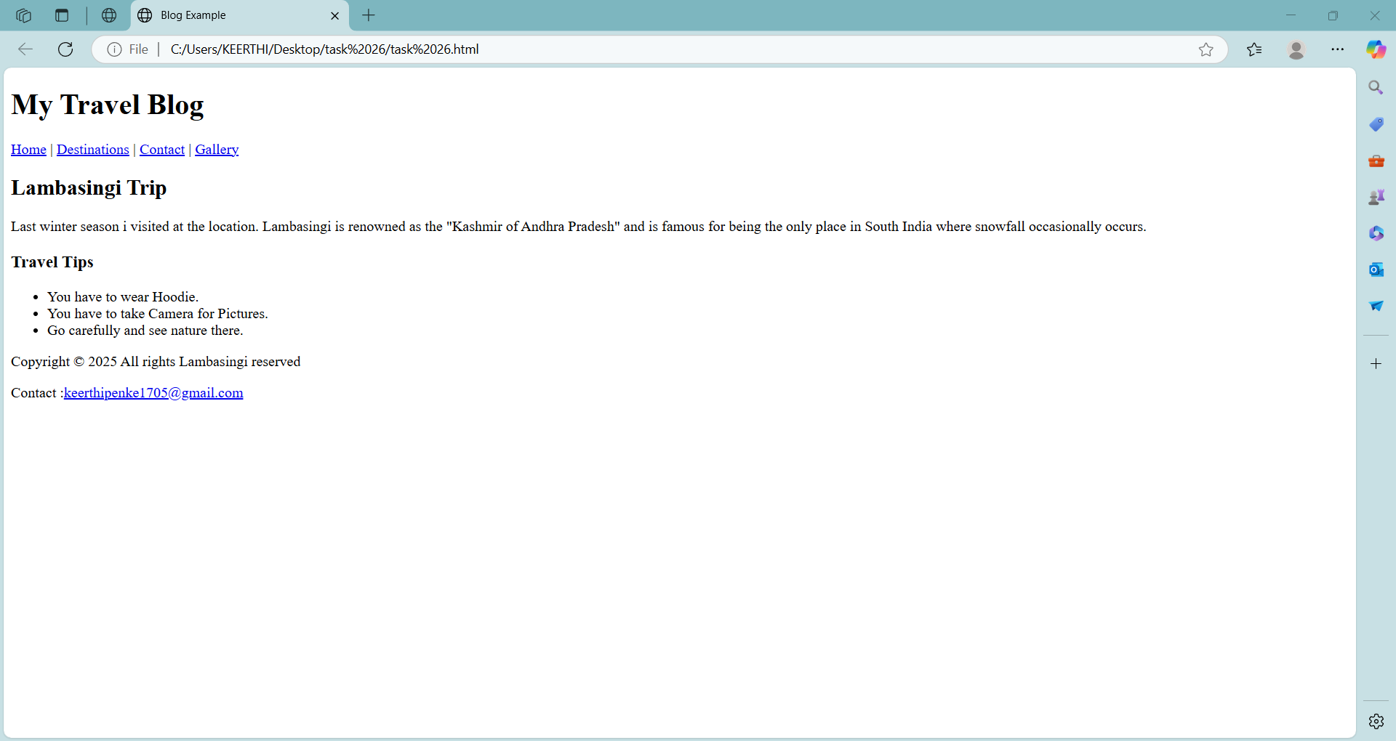

**Task-27**

**Title:** Simulate a science or math article:

**Code:**

<!DOCTYPE html>

<html>

<head>

<title>Science or math article</title>

</head>

<body>

<h1>Science and Math article</h1>

<p>Water chemical formula is H<sub>2</sub>O</p>

<p> This is the square of the number (2)<sup>2</sup>= 4</p>

<p><b>Famous Scientist</b>: <u>Albert einstein</u></p>

<p>Imagination is more important than knowledge. Knowledge is limited. Imagination encircles the world.</p>

</body>

</html>

**Output:**

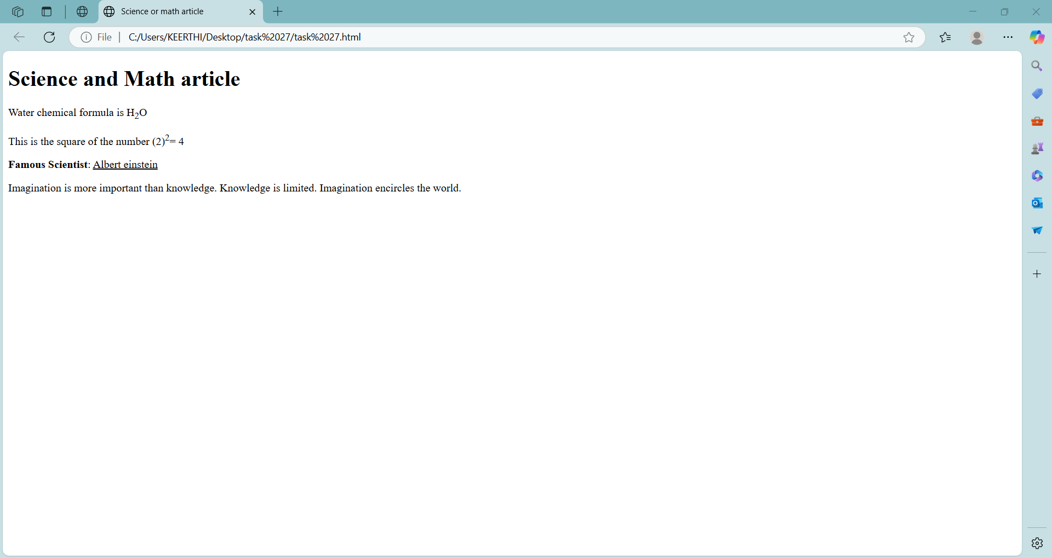

**Task-28**

**Title:** Create a support form:

**Code:**

<!DOCTYPE html>

<html>

<head>

<title>Support Form</title>

</head>

<body>

<fieldset>

<h2>Delivery Info</h2>

<form>

Full Name: <input type="text"></input><br><br>

mobile no.: <input type="text"></input><br><br>

Address : <textarea id="address" name="address" rows="4" required></textarea><br><br>

</form>

</fieldset>

</body>

</html>

**Output:**

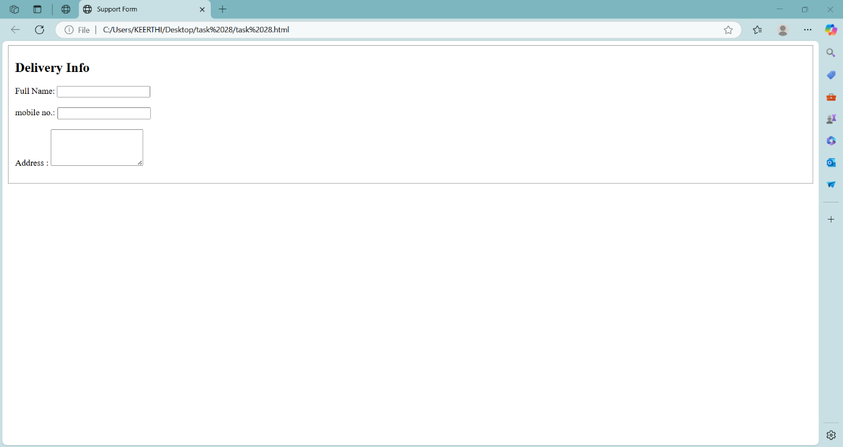

**Task-29**

**Title:** Develop a mini photo gallery:

**Code:**

<!DOCTYPE html>

<html>

<head>

<title>My Travel Gallery</title>

</head>

<body>

<h1>My Favorite Places</h1>

<div>

<form>

<img src="C:\Users\KEERTHI\Pictures\Vizag beach.jpg" alt="City" width="300px" height="300">

<p>This is the best place for tourists can enjoy holidays.</p>

</form>

<form>

<img src="https://assets.onecompiler.app/43fgp4rc9/43gcx66tg/hope%20island" alt="Hope island" width="300px" height="300px">

<p>There is a Hope island near to kakinada.</p>

</form>

</div>

</body>

</html>

**Output:**



